# How to set up self-assessment on CARS

**Resources to be made available**

1. Self-assessment tool (on CARS)
2. Guidance document (PDF)
3. Excel spreadsheet to aid data collection from case notes
4. Copy of self-assessment questions for reference

Add 2-4 to the Resources section by going to Admin🡪 Management 🡪Project Resources

Select Site and the self-assessment from the dropdown menus, choose your file and click Upload:

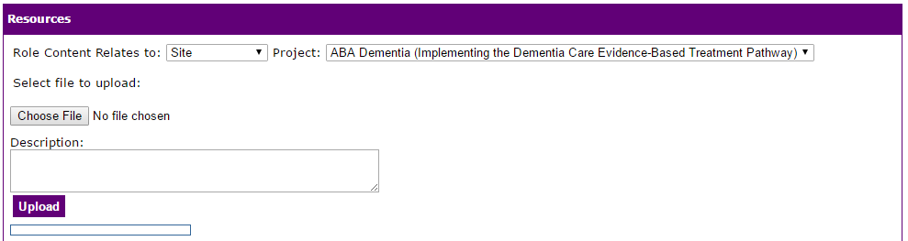

**Resources will need to be uploaded for your project**

* Update dates in the Guidance document before creating a PDF and placing it in Resources
* Check data collection spreadsheet before uploading it
* A reference copy of the self-assessment questions needs to be created for your project – please create one.

**Home page content**

This is what a user will see when they visit CARS home page after logging in. There is a right and left section which can be edited:

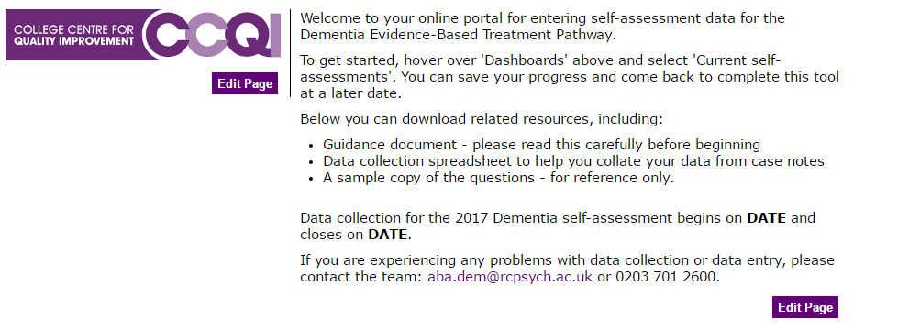

When you log in as an admin, different content will be displayed. Click Edit Page on either section to add content (see next screen shot).

Place the project logo in the left section by clicking on the landscape picture icon (circled). You will need a web address for pictures

Important: Resize logos to 300 width in the picture upload window or they will overlap the right-hand section.

Place your project blurb in the right-hand section.

Also Important: Make sure you edit the content for both Site and Public under ‘Role content relates to’. People logging in can see different content depending on how they are registered on CARS (as a ‘site’ or an ‘admin’ (you)).

I have placed text in here but dates on your ABA project content for Site and Public will need updating once you know when the self-assessment will be running. See the end for info about dates.

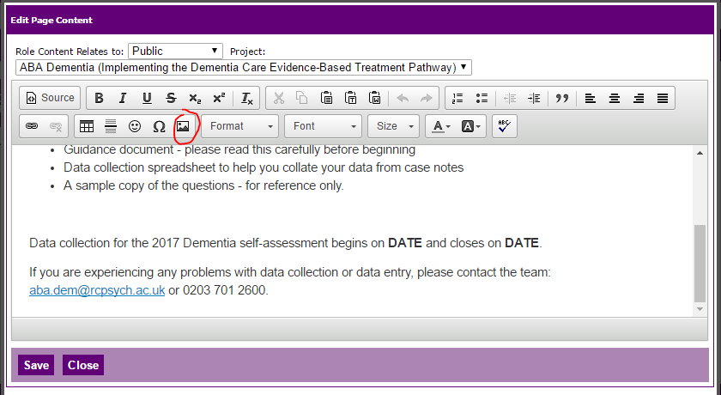

**How to edit questions on CARS (see next page for screenshot)**

Go to Admin🡪Management🡪Manage questionnaires

Click on the book icon to access the Sections.

Click on the book icon for each section to edit the questions therein.

Click on the pencil icon next to each question to edit it. It will appear at the top of the page in a text box.

Important: make sure you click Save after editing each question, or changes will not be saved.

Type = sort of question, e.g. Number (free text, digits only), radiobutton list (multiple choice), Text (free text). You can only edit this when you create the question for the first time. Important: ‘Reference’ type should be selected for all numerators, as they need to be related to the denominator. You need to select a Reference (the denominator question) from the dropdown box. CARS will check that all numerators are smaller than denominators and alert the user if there’s a mistake. The text of the denominator (and reference to the figure the user has already entered) will only appear if you tick ‘Display reference question’. This isn’t necessary if the numerator comes right after the denominator but will need to be ticked if it appears further down or in a different section.

Identifier = name you enter for the question e.g. Q1

Label = question itself

Mandatory = tick this to make question forced answer

I haven’t used any of the other options on this screen.

When no existing question is already selected, you can create a new question by entering details in the boxes which will be blank. Click Add at the end to complete this.

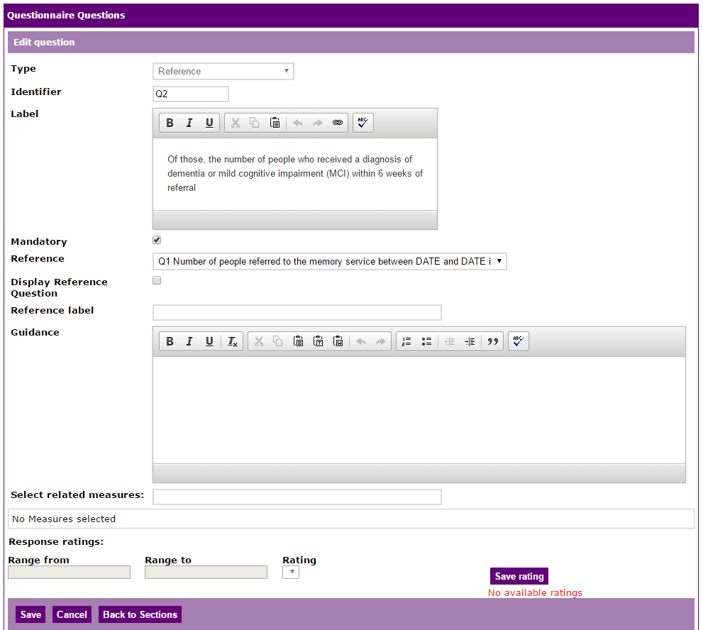

**Editing questionnaire options**

Go to Admin🡪Management🡪Manage questionnaires

Click on the pencil icon next to the self-assessment.

Set the start and end dates, and add a Thank You Note so that users will know when their submission has been successfully entered.

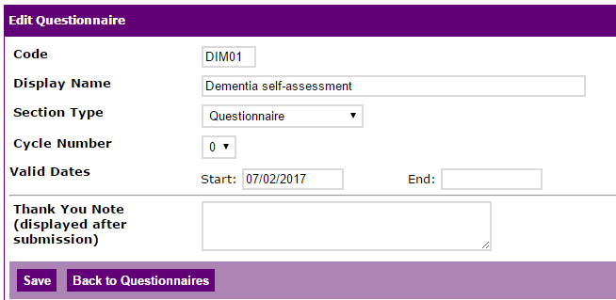

**Setting up Email templates**

There are 5 automatic email templates to edit:

1. Site Self Assessment Created: When registered, the lead person will get an email saying their account has been set up
2. Self Assessment Workbook Open – Notifies them when data collection starts
3. Reminder email – every 2 weeks each service will get a reminder that they need to complete it, unless they’ve finished and pressed Submit.
4. Site Self Assessment Thank You: an email sent to thank them for their submission, reminder that they’ll get a report once it’s all been checked, and note to say they can’t edit their data now and should email the team if they want to amend anything.
5. Site Self Assessment Complete: Notification to project staff that a service has completed self-assessment.

Go to Admin🡪Management🡪Email templates (see next screenshot)

Select the project, and then the email template you’d like to edit (ABA templates are at the end of the list).

Edit the subject (subject line of email) and content. Text between ## are placeholders and will insert the info automatically, like a mailmerge. Click the ## icon to add more placeholders if necessary.

Edit the email footer in the box below this. You can place the project logo in there and any contact details. It will be appended to all emails from that project.

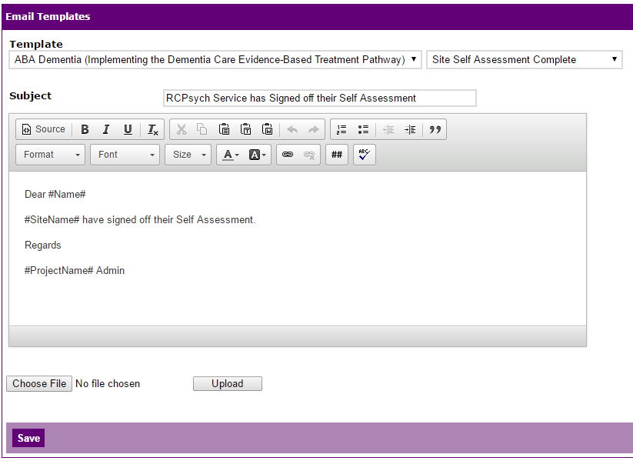

**Groups**

It is possible to create a group, so that all sites will be placed under the same self-assessment grouping. This means you can set them all the same start and end dates without having to do it individually.

This is a new function and I am not entirely sure how it works so you may need to work it out!

It is possible to edit these dates for individual services at a later stage, for example if you need to edit a service’s data after the deadline, but this will then remove the option of editing everyone’s dates together.

**Dates for self-assessment**

Questions relating to waiting times are for a 3-month period. This period must end 6 weeks before data collection begins, and start 3 months before that. This is to allow people referred on the last day of the 3-month period time to have worked through the system.

Other questions relate to a 12-month period. This period must end the day before data collection starts and begin a year before that.

Important: I’ve left in the period in brackets in the questions. This is just a reminder and can be removed once the dates are placed in there.